Genre selected was RnB

2a, b)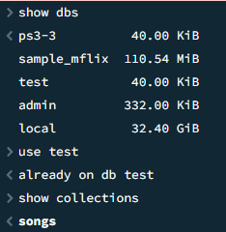

Query couldn’t fit in screenshot

2d)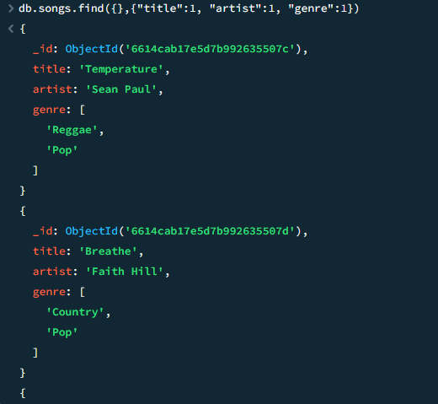

Query didn’t fit in screenshot

Genre selected was “Pop”

Selected country and pop